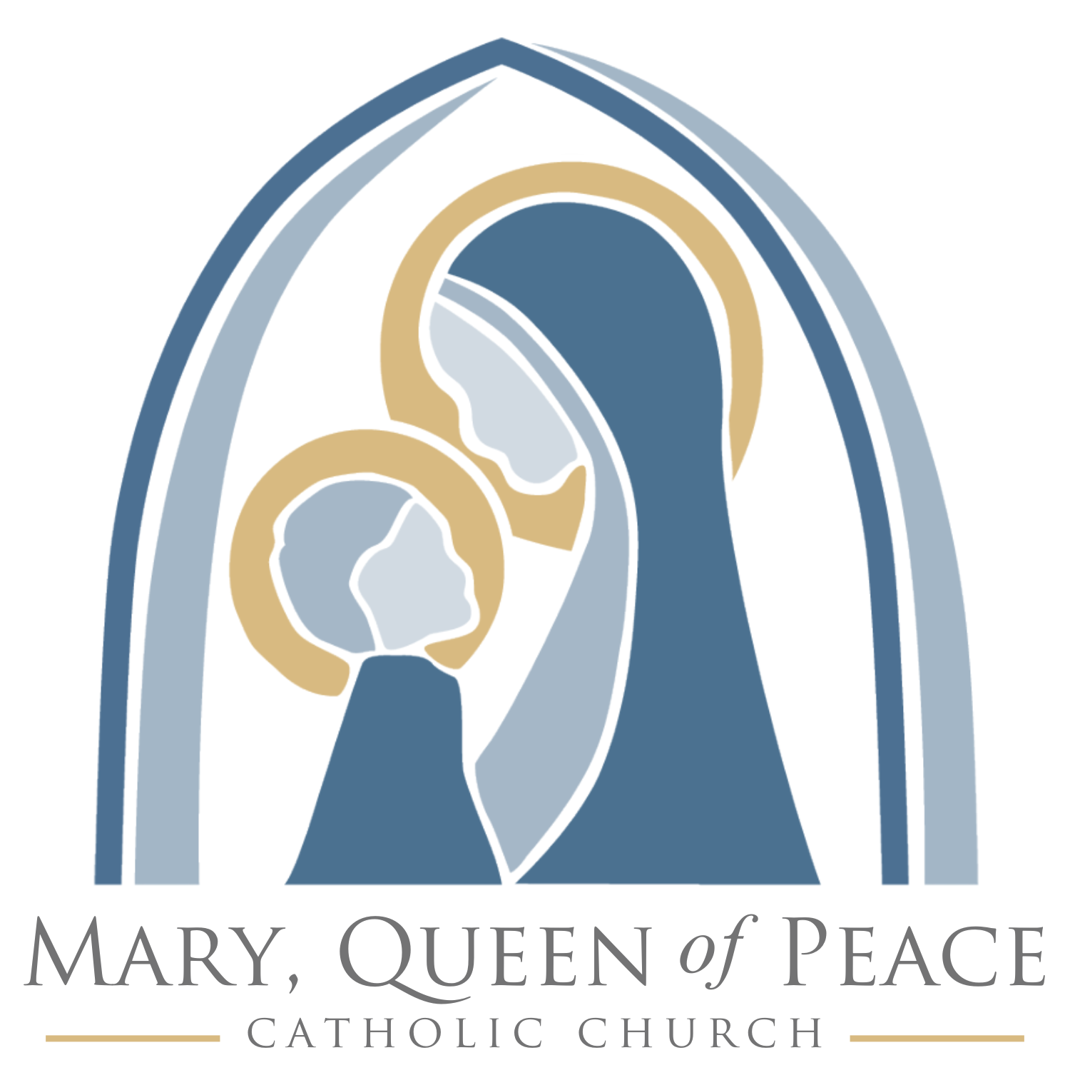

MARY, QUEEN OF PEACE CATHOLIC CHURCH – MANDEVILLE, LOUISIANA
Co-Director of Evangelization, Engagement, and Adult Formation

The task of evangelizing all people constitutes the essential mission of the Church. Evangelizing is in fact the grace and vocation proper to the Church, her deepest identity. She exists in order to evangelize.
~ On Evangelization in the Modern World, 14.

Mary, Queen of Peace Catholic Church is looking for a Co-Director of Evangelization, Engagement, and Adult Formation. The Co-Director of Evangelization, Engagement, and Adult Formation, working collaboratively with his/her counterpart, attends to active parishioners, nominal Catholics, the inactive community, and the unchurched – responsible for leading and overseeing the parish's efforts to share the Christian faith and bring new people into the church community. This role often involves developing and implementing evangelism strategies, training parishioners in evangelism, and fostering a culture of outreach and mission.

Goals of the position include:
- Fostering conversion and growth in discipleship formation among the faithful.
- Developing and implementing evangelism strategies, a coherent discipleship pathway, systematic lay formation and gift discernment.
- Engage and accompany parishioners on the journey of becoming intentional, activated disciples.
- Equip parishioners with the skills and knowledge to share their faith effectively.
- Cultivate a church culture where evangelism is seen as a vital part of every parishioner's life and ministry.
- Implementing and supporting adult faith formation (catechetical) programs/ministries.
- Fostering adult discipleship groups and small Christian communities.
- Animating and equipping parishioners to evangelize by witness, word, and action.
- Implementing new initiatives to foster personal encounters with Jesus Christ.
- Forming small Christian communities.
- Equipping parishioners to become stewards who are missionary disciples.

Ministerial Character
The Pastor is the visible principle and foundation of unity in Mary, Queen of Peace Catholic Church, which the Archbishop has entrusted to him. He makes Christ’s mission present and enduring in the parish. In order to fulfill his mission, the Pastor employs suitable, chosen collaborators (clerics, religious, or laypeople). He shares with them his mission and entrusts various responsibilities to them.

Positions employed at Mary, Queen of Peace Catholic Church help to extend the ministry of the Pastor in particular ways as outlined in the job description. Therefore, the employee in this position is closely connected to and assists the Pastor in the performance of his ministry and thereby engages in ministry for the Church.

Job Summary
The Co-Directors of Evangelization, Engagement, and Adult Formation are the pastoral team members charged with assisting the Pastor in the formation of the parish in the Catholic faith. These pastoral team members develop, maintain, and administer the evangelization and catechetical programs for all adults of Mary, Queen of Peace Catholic Church. These ministers work with the pastor, pastoral team, and parishioner volunteer leaders to create opportunities for people to encounter Jesus Christ and His Church and grow as disciples by fostering small group ministry, parish retreats, and kerygmatic presentations of the faith. As a team, they effectively manage all aspects of Christian formation and evangelization. These ministers share the Good News in fresh and innovative ways with both the “un-churched” and those in the pews in need of re-evangelization.

These ministers provide vision, organization, short- and long-range planning, leadership, supervision, and coordination of faith formation programs and processes in the parish. This role will be responsible for engaging and empowering lay leaders for key areas of adult ministry, organizing those leaders into a collaborative team and providing management oversight for the group. Administrative oversight and tasks for Evangelization, Engagement, and Adult Formation programs, events and resources are also included in the responsibilities of this role.

The position focuses on Christian initiation of adults and children over the age of 7; coordination of our Adult Faith Formation team and parish activities affiliated with the team; coordination, collaboration, and support of adult faith ministries, small groups, and lay formation. The Directors of Evangelization, Engagement, and Adult Formation continually assess the needs of parish adults in the areas of spiritual, intellectual, emotional, and religious growth while helping adults identify their gifts and use those gifts to further the kingdom. These pastoral ministers are responsible for helping people enhance their personal relationship with God. Given the Church’s teaching that adult faith formation is the chief form of catechesis and the catechetical priority of the Church, assisting with adult faith formation, OCI, and evangelization efforts are essential responsibilities of this position. Engaging adults, especially parents, is of prime significance for the faith formation efforts of the parish to be successful.

The Directors of Evangelization, Engagement, and Adult Formation work with a three-fold vision:
- To bring about in all Catholics such an enthusiasm for their faith that, in living their faith in Jesus, they freely share it with others (Evangelism Strategies and Training and Equipping Parishioners)
- To invite all people within our geographical reach, whatever their social or cultural background, to hear the message of salvation in Jesus Christ so they may come to join us in the fullness of the Catholic faith (Fostering a Culture of Evangelization, Engagement and Connection)
- To accompany others along the discipleship pathway and the journey of lay formation so that they may encounter our Trinitarian God, experience conversion of heart, and become intentional disciples of Jesus (Discipleship Pathway, Lay Formation, Gift Discernment)

The position reports to the Pastor, collaborates with the clergy, parish staff, lay ministry leaders, and operates with latitude for the use of independent judgment and initiative. The Directors of Evangelization, Engagement, and Adult Faith Formation must understand the nature and purpose of team organization and management, catechesis, evangelization, pastoral ministry, and continuously assess the needs and priorities of the parish, working with the pastor, clergy, parish staff, volunteers, parents, and parishioners. This individual will be expected to demonstrate good public relations skills, as well as teaching skills.

Essential Duties: (Overarching)
- Foster a warm, Christ-centered welcome for all visitors, demonstrating our commitment to Radical Hospitality.
- Be attentive and present to those served and those you serve alongside, practicing our Fundamentally Relational value.
- Seek opportunities to improve systems and processes in a spirit of Innovative Excellence, thinking beyond the norm to better serve parish needs.
- Collaborate across departments and ministries with humility and openness, maintaining a mission-first mindset in line with being Mission Driven.
- Support and uphold the teachings of the Catholic Church and the mission of the parish in both your professional and personal life.
- Act as a witness to Gospel values by modeling the teachings of the Roman Catholic Church.
- Continuously grow in your ministry by participating in ongoing professional and personal faith formation.
- Identify and implement programs and initiatives that teach, form and inspire parishioners to become missionary disciples.
- Identify and engage resources and volunteers to assist with Evangelization, Engagement, and Adult Formation activities.
- Connect parishioners, especially new to the parish, with appropriate staff, lay ministry leaders and fellow parishioners based on their state of life, formation needs and spiritual goals.
- Collaborate with the Director of Communications and Media in promotion and marketing of all Evangelization, Engagement, and Adult Formation parish programs, events, and special guest speakers ensuring all available information is maintained and accurate.
- Ensure compliance with all Archdiocese of New Orleans policies and procedures including Safe Environment protocols.
- Participate in parish staff and diocesan meetings and trainings.
- Maintain a work schedule that maximizes availability and accessibility.

Essential Duties: (Director of Evangelization)
- Collaborate with the pastor, staff, and other committees to plan and implement strategies in order to reach active parishioners, inactive Catholics, and the unchurched in the community.
- Design and coordinate event opportunities of evangelization. This includes the recruitment and formation of volunteers/ministry leaders for such opportunities.
- Assist the Pastor in implementing a Discipleship Pathway that helps people Encounter Jesus Christ, grow in their knowledge and love of Christ and His Church, and live out their discipleship as they serve in the parish and community.
- Implement programming and opportunities at key stages to help people progress along a path: Kerygmatic Presentations, Retreats, Small Groups, Called and Gifted, Alpha, etc.
- Develop a strategy to form missionary disciples, facilitate small group discipleship, spiritual mentorship, faith formation, all in preparation for sending forth missionary disciples.
- Develop Lay Formation for parishioners to embrace their role as engines of evangelization.
- Cultivate a church culture where evangelism is seen as a vital part of every member's life and ministry.
- Collaborate with the Director of Missionary Discipleship to ensure the success of the ACTS retreat for Men and Women and Adult Confirmation.
- Collaborate with the Director of Marriage, Family Life and Women’s Ministry on marriage enrichment, human sexuality, intentional family life, and ministry to women.
- Contribute to the faith formation and development of ministers and parishioners.
- Demonstrate an interest in the initiation of new members to the parish community and in the process of evangelization and renewal.
- Contribute to the initial formation and ongoing development of various ministers and parish groups.
- Participate in the recruitment, training, formation, supervision, and empowering others.
- Assist in the formation of the entire community in understanding the parish mission.
- Develop or assist with parish retreats (Lenten Mission, Summit Nights, etc.), missions, and formation events.
- Other duties as assigned.

Essential Duties: (Director of Engagement)
- Cultivate effective pathways for new and old parishioners of MQP to connect with others and grow in their faith.
- Work alongside the clergy and pastoral team in identifying and developing people’s gifts and connecting those gifts with opportunities to serve in the various ministries of the parish – recruiting and mobilizing volunteers. Develop a process of helping everyone in the church family come to full participation in the community life of our parish so they are using their gifts in ministry and ministered to as needed.
- Assist the pastoral staff in inviting parishioners and visitors to take the next step in the MQP discipleship pathway to encounter Jesus, experience conversion, and use their time, talents, and treasure for the good of the Lord and His church.
- Assist the pastoral staff in moving individuals from nominal Catholics, to intentional disciples, to missionary disciples who are trained and formed to embrace their personal apostolate of evangelization and recreation.

Essential Duties: (Director of Adult Formation)
- Take leadership in helping the parish to shape its goals and strategies for adult faith formation according to the vision of Our Hearts Were Burning within Us.
- Assist parish staff, groups, and organizations to identify opportunities, acquire resources, and plan formats and programs for adult formation within their established settings and ministries.
- Oversee and plan all aspects of the OCI process for those seeking to become Catholic or who are in need of sacraments.
- Plan and promote an annual calendar of adult programming and formational opportunities.
- Conduct program evaluations and parish-wide assessments to determine effectiveness of opportunities and refine efforts.

Knowledge, Skills, and Abilities
- Knowledge of the structure and basic teachings of the Roman Catholic Church.
- Knowledge of ministry of catechesis and evangelization
- Skill in communicating with diverse audiences both oral and written.
- Ability to build and manage teams and resources, modeling with integrity, inspiring a vision and encouraging the heart.
- Ability to operate various word-processing software, spreadsheets, and database
Programs (Microsoft Office preferred).
- Ability to excel in professional relationships and work effectively with staff, clergy, and laity.
- Ability to organize, prioritize, carry out multiple tasks, meet deadlines and utilize effective time management techniques.
- Ability to maintain confidentiality at all times.
- Ability to follow instructions furnished in verbal or written format.

Minimum Qualifications
- Bachelor’s degree from an accredited college or university with coursework in theology, religious education, pastoral ministry, or a related field is preferred.
- Experience in pastoral ministry is preferred.
- Must be a practicing Roman Catholic in good standing with the Church.
Interested applicants should send a cover letter, resume, and references to kbaker@maryqueenofpeace.org. For questions or additional information, please contact our Director of Parish Operations and Stewardship, Karen Baker, at (985) 202-0232.
Updated: July 4, 2025

