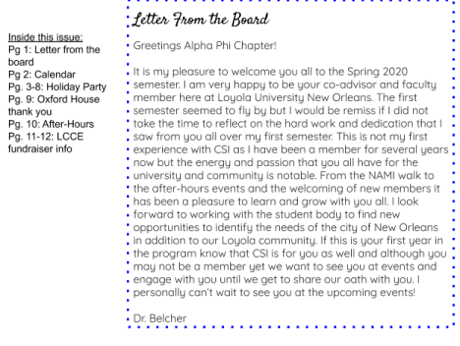CHI SIGMA IOTA ELIGIBILITY
Students are invited to join CSI during the Fall and Spring Semesters. Consideration is based on the following criteria from our chapter by-laws:
4.1 The following shall be deemed eligible for membership in the Society through endorsement of their chapter:
4.1.1 Students: Those students who are enrolled in a counselor education program leading to graduate degrees (Master's, specialist, or doctorate).
4.1.1.1 They shall have completed the equivalent of at least one full
academic term (semester or quarter) of counseling courses carrying
approved graduate credit as defined by the institution and are deemed
promising for endorsement as a professional counselor whose ethical
judgment and behavior will be exemplary.
4.1.1.2 They must have maintained an overall scholastic grade point
average of 3.5 or better (on a 4.0 system), or the equivalent, while enrolled in the program.
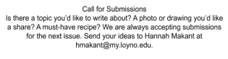
ℂ�������������� ���� ���������������� ������������!
February:
4: LCCE fundraiser: Masquerade for
Mental Health @ Southern Rep
Theatre
11-14: Law & Ethics Conference
24-28: Mardi Gras break!
March:
6-7: LAPT Conference
30: Summer/Fall Registration begins
April:
2: Graduate Research Symposium
CSI Spring Initiation
3: President Tetlow Domestic
Violence Presentation
18: CSI annual Crawfish boil!
24: LACES conference
Welcome and thank you, Dr. Belcher!
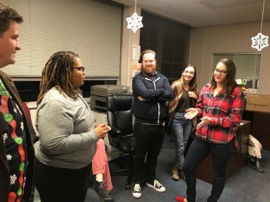
As a part of our CSI initiation, we welcomed Dr. Belcher into our Alpha Phi chapter and thanked her for jumping right in and serving on the CSI board as Faculty Advisor.
CONGRATULATIONS! Our newest CSI Alpha Phi members were initiated at our annual Holiday Party.
Kalle Allison , Amy Craft, Frances Maples, Maddi Barbor, Soren Ramsey, Mary Beth Moore, Stephen Byrd, Diana Mirfiq, Christine Johnson, Melissa Ridley, Laura Alexander, Dario Bayardo
Not pictured: Jordan Esfeld, Stacy Louis-Goins
CSI members and their cake :)
Holiday Party food and fun!
White Elephant/Dirty Santa game:
CSI and the rest of the Loyola Counseling department donated items gathered from our Holiday party to Oxford House New Orleans. Together we donated two large boxes of paper towels, toiletries, and other
necessities.
Dear Chi Sigma Iota of Loyola University:
Words cannot begin to express the amount of gratitude we have for your
generosity. We are humbled and honored by your decision to host a donation drive on behalf of Oxford House this past holiday season. We offer this letter as a formal thank you for your support. With your donations, we will be better able to provide for those new residents who truly have no resources to obtain the bare necessities for day-2-day living.
On January 1st, we opened a new men’s house in the Greater New Orleans area that provides sober, supportive housing support for 9 men in recovery. These donations will be given to Oxford House Beignet on your behalf. They will be elated to receive the plethora of items you’ve collected for them.
Gratefully yours,
Jeremy J Weatherspoon, CPSS
Outreach Services Representative
Oxford House, Inc.
602.625.0960 (cell)
www.oxfordhouse.org www.oxfordhousela.org
CSI After-Hours
LCCE Masquerade for Mental Health
Thank you to everyone who supported the Masquerade for Mental Health! Whether
you wrangled or donated silent auction items, worked the event, bid in the auction, and/or showed up to celebrate with us: you were an integral part of a successful
fundraiser in its inaugural year. We were able to raise some funds to support direct services and the long term sustainability of the Loyola Center for Counseling and Education. If you missed the Masquerade, we hope to see you there next year!! Happy Carnival 2020! Kind thanks,
~Sarah Zoghbi

